Accounts Payable Considerations:

Accounts Payable – Received by August 31 – No Invoice received until books are Closed.
After discussions with multiple auditors, one of the areas they felt needed further explanation was in the way we should handle Accounts Payable for goods and/or services ordered and received by August 31, but for which, NO INVOICE has been received by the time we are ready to close our books for Fiscal Year 9.

- These payments should be entered into File ID 9 as a PA,
- Charge the expense to the correct expenditure account (6XXX) and
- Allowing TxEIS to post to the appropriate liability account (2XXX).

This ensures the expenses are shown in the correct fiscal year (File ID 9). However, at this point in the process,
- We no longer want to actually print checks in File ID 9.
- We will actually print the check in the Current File ID, paying from the liability account (2XXX). Your step-by-step is shown here:

Scenario:
We ordered some school supplies from Office Depot on August 15, 2019.

The order was received in full on August 29, 2019, however it is now September 15, 2019.

We have begun processing all transactions in the new File ID C.

We received the invoice for the supplies on Sept 16, 2019, in time to process during our regular AP check run on Sept 22, 2019.

In Finance > File ID 9 > Maintenance > Postings > Check Processing PA tab, add a PA to Office Depot for the amount of the expenses, charged to the appropriate expenditure account(s) and Save.

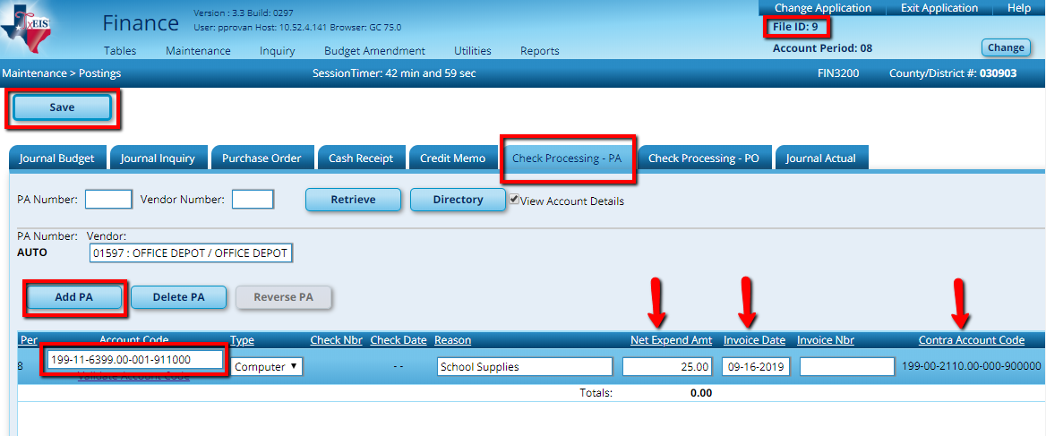

If you scroll to the right, notice the Contra Account. This credits the liability account for us. Note the PA number upon saving. It is a good practice to reference this number when we actually print the check in File ID C.

When we roll balances for our balance sheet accounts in File ID 9 to File ID C (or receive opening entries from our auditors), this amount will be included in the liability account.

When the invoice is received and we are ready to pay, log into

Finance > File ID C > Maintenance > Postings > Check Processing PA tab

- Add a PA for Office Depot.
- Charge this to the liability account code in Fiscal Year 0 and reference the PA # from File ID 9.
- Save and process the check as usual.

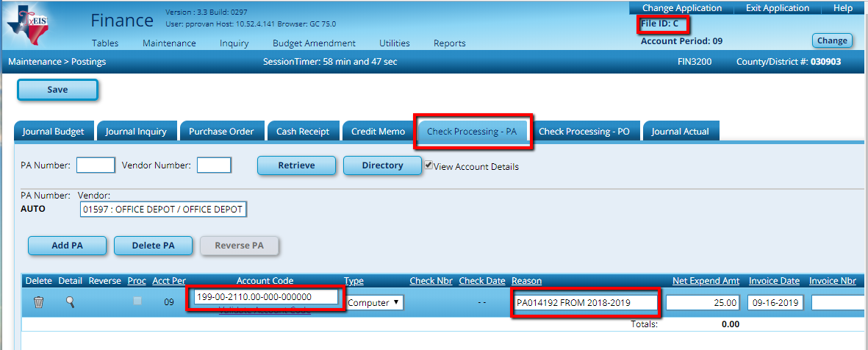

Note:
- You may use a different liability account to set these expenditures apart. Some districts chose to use a sub-object for this. (199-00-2110.01-000-0-00000)
TxEIS automatically uses the liability options.

Tables > District Finance Options > Clearing fund Maintenance tab.

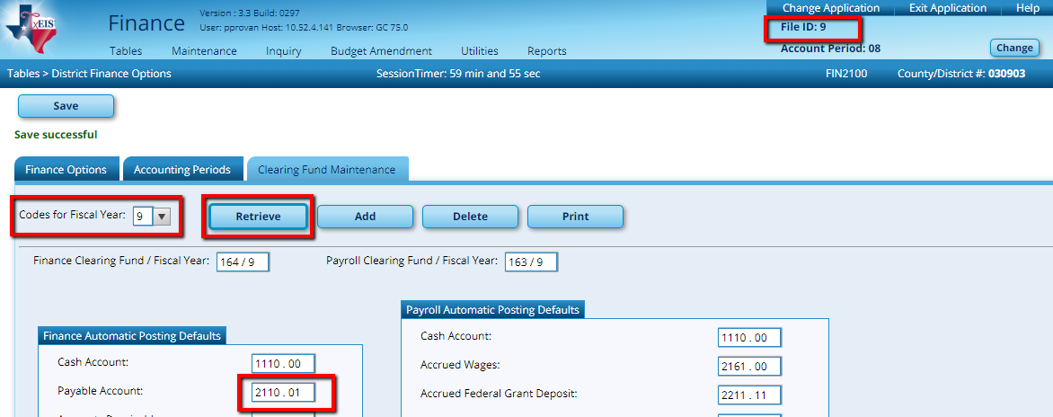

To utilize a subobject, change here and save. You must be completely finished with all check runs in the old File ID however, so these expenses are kept separate from those that processed duing the year.

- Your auditor may prefer you use a date of September 1 to further ease identification.

Note: It is important that you add all necessary PAs in File ID 9 BEFORE you send your file to your auditor. If you enter another check that should be charged to expenses in File ID 9 after giving the file to your auditor, contact them immediately. They will likely require a new file from you and this may delay your audit.

